**Supplementary Materials for manuscript: The ectoparasites of hybrid ducks in New Zealand (Mallard x Grey Duck)**

Mariana Bulgarella, Mathieu Quenu, Lara D. Shepherd and Mary Morgan-Richards

*International Journal for Parasitology: Parasites and Wildlife*

**Supplementary Table S1.** List of the forty ducks collected showing their phenotypic score, sex and the mitochondrial DNA haplotypes of the host and a subset of their lice. Letters correspond to the haplotype shown in the networks. Bold means haplotype is exclusive to Grey Duck-like hybrids.

|  |  |  |  |  |  |  |  |  |  |
| --- | --- | --- | --- | --- | --- | --- | --- | --- | --- |
| DNA matches more closely | Duck  ID | Sex | Phenotype  score | | duck CR  haplotype | duck CO1  haplotype | *Anatoecus*  CO1 haplotype/s | *Trinoton*  CO1 haplotype/s | *Anaticola*  CO1 haplotype/s |
|  |
| *A. platyrhynchos* | 12841 | Male |  | | A | A | A | B |  |
| *A. platyrhynchos* | 12842 | Male |  |  | A | A |  | D |  |
| *A. platyrhynchos* | 12843 | Male |  | | A | B | A | B | A |
| *A. superciliosa* | 12850 | Female | 16 | | **F** | **E** | Ax4, **C, E** | B, **E** | A, **E, F** |
| *A. platyrhynchos* | 12851 | Female | 11 | | A | B | Ax5, B, D | B, C | Ax2, B |
| *A. platyrhynchos* | 12852 | Male | 14 | | A | B |  |  |  |
| *A. platyrhynchos* | 12853 | Female | 17 | | A | B |  |  |  |
| *A. superciliosa* | 12854 | Female | 14 | | **G** | **D** | A |  | A |
| *A. platyrhynchos* | 12855 | Male | 24 | | A | C |  |  |  |
| *A. platyrhynchos* | 12856 | Male | 22 | | B | A |  |  |  |
| *A. platyrhynchos* | 12857 | Male | 13 | | D | A |  | A, Bx2 |  |
| *A. platyrhynchos* | 12858 | Male | 21 | | A | B |  |  |  |
| *A. platyrhynchos* | 12859 | Male | 25 | | A | B | Ax8 |  | Ax2, C, D |
| *A. platyrhynchos* | 12860 | Female | 18 | | A | B |  |  |  |
| *A. platyrhynchos* | 12861 | Male | 22 | | C | A |  |  |  |
| *A. platyrhynchos* | 12862 | Male | 18 | | A | A |  |  |  |
| *A. platyrhynchos* | 12863 | Male | 21 | | B | A |  |  |  |
| *A. platyrhynchos* | 12864 | Female | 18 | | A | B |  | Ax3, B |  |
| *A. platyrhynchos* | 12865 | Male | 23 | | A | B |  | B, C | A |
| *A. platyrhynchos* | 12866 | Male | 23 | | A | B |  | B |  |
| *A. platyrhynchos* | 12867 | Male | 22 | | A | A |  |  | Ax3 |
| *A. platyrhynchos* | 12868 | Male | 23 | | A | A |  |  |  |
| *A. platyrhynchos* | 12869 | Female | 19 | | A | A |  | C |  |
| *A. platyrhynchos* | 12870 | Male | 24 | | A | A |  |  |  |
| *A. platyrhynchos* | 12871 | Male | 16.5 | | B | A |  |  |  |
| *A. platyrhynchos* | 12872 | Male | 24 | | A | B |  |  |  |
| *A. platyrhynchos* | 12873 | Male | 18 | | B | A |  |  |  |
| *A. platyrhynchos* | 12874 | Male | 18 | | C | A |  |  |  |
| *A. superciliosa* | 12875 | Male | 17 | | **G** | **F** |  |  |  |
| *A. platyrhynchos* | 12876 | Male | 21 | | E | A |  |  |  |
| *A. platyrhynchos* | 12877 | Male | 24 | | A | B |  |  |  |
| *A. platyrhynchos* | 12878 | Male | 22 | | A | A |  | B, C |  |
| *A. platyrhynchos* | 12879 | Male | 18.5 | | A | A |  |  |  |
| *A. platyrhynchos* | 12880 | Male | 15 | | B | A |  | Bx2 |  |
| *A. platyrhynchos* | 12881 | Male | 19 | | A | A |  | A, C |  |
| *A. platyrhynchos* | 12882 | Male | 20 | | A | B |  |  |  |
| *A. platyrhynchos* | 12883 | Male | 19 | | A | B |  |  |  |
| *A. platyrhynchos* | 12884 | Female | 16 | | A | B |  |  |  |
| *A. platyrhynchos* | 12885 | Female | 15.5 | | A | A |  |  |  |
| *A. platyrhynchos* | 12886 | Female | 16 | | A | A |  |  |  |

**Supplementary Figure S1.** Correlogram or matrix correlation of the phenotypic measurement variables. The numbers correspond to the values of the correlation coefficients. tmt = tarsometatarsus.

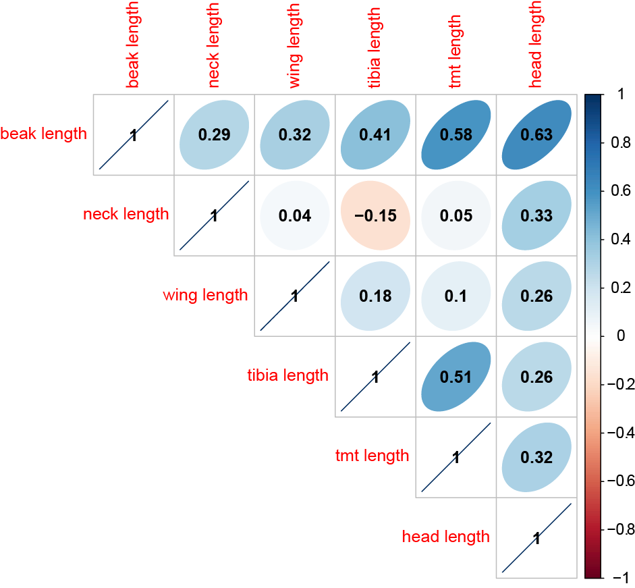

**Supplementary Figure S2.** Bayesian phylogeny of Anaticola crassicornis based on 378 bp of CO1 gene from Escalante et al. (2016) with the addition of 16 new sequences from New Zealand hosts. The values above branches are posterior probabilities. The scale bar indicates nucleotide substitutions per site along the branch lengths. This is the full tree that includes the 76 CO1 sequences downloaded from GenBank.

